LAPORAN TUGAS
WORKSHOP SISTEM INFROMASI WEB SERVER
(TIF330805)
MINGGU KE-4 Pertemuan 2
SEMESTER III



ACARA 8
PDO, Prepared Statement, Relasi, dan CRUD Lengkap

Disusun Oleh :

Rezza Wahyu Setya Adhy (E41250211)
Golongan A

PROGRAM STUDI DI LUAR KAMPUS UTAMA (PSDKU)
TEKNIK INFORMATIKA KAB. NGANJUK
JURUSAN TEKNOLOGI INFORMASI
POLITEKNIK NEGERI JEMBER
TAHUN 2026
- Studi Kasus
Seorang mahasiswa mengetik di form pencarian: ' OR '1'='1. Jika query digabung langsung dengan string, seluruh data bisa bocor (SQL Injection). Prepared statement memisahkan query dan data, sehingga input berbahaya diperlakukan sebagai data biasa, bukan perintah SQL.
- Tujuan
Mahasiswa menyelesaikan CRUD penuh untuk ketiga resource (Mahasiswa, Prodi, Mata Kuliah) menggunakan PDO prepared statement dan Bootstrap.
- Langkah
- Implementasikan Database class singleton dengan PDO.
- app/Core/Database.php
<?php

namespace App\Core;

use PDO;

class Database
{
private static ?PDO $instance = null;

public static function getInstance(): PDO
{
if (self::$instance === null) {
$config = require __DIR__ . '/../../config/database.php';
$dsn = "mysql:host={$config['host']};dbname={$config['dbname']};charset={$config['charset']}";

self::$instance = new PDO($dsn, $config['username'], $config['password'], [
PDO::ATTR_ERRMODE => PDO::ERRMODE_EXCEPTION,
PDO::ATTR_DEFAULT_FETCH_MODE => PDO::FETCH_ASSOC,
PDO::ATTR_EMULATE_PREPARES => false,
]);
}
return self::$instance;
}
}

- Buat Repository atau method di Model untuk all, find, create, update, delete.
- app/Models/MahasiswaModel.php
<?php

namespace App\Models;

use App\Core\Model;

class MahasiswaModel extends Model
{
// ===== STUDI KASUS (ACARA 8): JOIN ke prodi =====
public function all(): array
{
$sql = "SELECT m.*, p.nama AS prodi_nama
FROM mahasiswa m
JOIN prodi p ON m.prodi_id = p.id
ORDER BY m.nim";
return $this->db->query($sql)->fetchAll();
}

public function find(int $id): ?array
{
$stmt = $this->db->prepare("SELECT * FROM mahasiswa WHERE id = :id");
$stmt->execute(['id' => $id]);
$result = $stmt->fetch();
return $result ?: null;
}

public function create(array $data): bool
{
$sql = "INSERT INTO mahasiswa (nim, nama, email, prodi_id, angkatan)
VALUES (:nim, :nama, :email, :prodi_id, :angkatan)";
$stmt = $this->db->prepare($sql);
return $stmt->execute($data);
}

public function update(int $id, array $data): bool
{
$sql = "UPDATE mahasiswa
SET nim = :nim, nama = :nama, email = :email,
prodi_id = :prodi_id, angkatan = :angkatan
WHERE id = :id";
$data['id'] = $id;
$stmt = $this->db->prepare($sql);
return $stmt->execute($data);
}

public function delete(int $id): bool
{
$stmt = $this->db->prepare("DELETE FROM mahasiswa WHERE id = :id");
return $stmt->execute(['id' => $id]);
}
// ===== AKHIR STUDI KASUS (ACARA 8) =====

// ===== TUGAS MANDIRI (ACARA 8): pencarian pakai LIKE =====
public function search(string $keyword): array
{
$sql = "SELECT m.*, p.nama AS prodi_nama
FROM mahasiswa m
JOIN prodi p ON m.prodi_id = p.id
WHERE m.nama LIKE :keyword1 OR m.nim LIKE :keyword2
ORDER BY m.nim";
$stmt = $this->db->prepare($sql);
$stmt->execute([
'keyword1' => "%{$keyword}%",
'keyword2' => "%{$keyword}%",
]);
return $stmt->fetchAll();
}
// ===== AKHIR TUGAS MANDIRI (ACARA 8) =====
}
- Lengkapi Controller + View untuk CRUD Mahasiswa.
- app/Controllers/MahasiswaController.php
<?php

namespace App\Controllers;

use App\Models\MahasiswaModel;
use App\Models\ProdiModel;

require_once __DIR__ . '/../Core/Database.php';
require_once __DIR__ . '/../Core/Model.php';
require_once __DIR__ . '/../Models/MahasiswaModel.php';
require_once __DIR__ . '/../Models/ProdiModel.php';

class MahasiswaController
{
public function index(): void
{
global $base;

$model = new MahasiswaModel();

// ===== TUGAS MANDIRI (ACARA 8): pencarian =====
$keyword = trim($_GET['q'] ?? '');
$daftarMahasiswa = $keyword !== ''
? $model->search($keyword)
: $model->all();
// ===== AKHIR TUGAS MANDIRI (ACARA 8) =====

require __DIR__ . '/../Views/mahasiswa/list.php';
}

public function create(): void
{
global $base;
$prodiModel = new ProdiModel();
$daftarProdi = $prodiModel->all();
$error = null;

require __DIR__ . '/../Views/mahasiswa/create.php';
}

public function store(): void
{
global $base;

$data = [
'nim' => trim($_POST['nim'] ?? ''),
'nama' => trim($_POST['nama'] ?? ''),
'email' => trim($_POST['email'] ?? ''),
'prodi_id' => (int)($_POST['prodi_id'] ?? 0),
'angkatan' => (int)($_POST['angkatan'] ?? date('Y')),
];

if ($data['nim'] === '' || $data['nama'] === '') {
header('Location: ' . $base . '/mahasiswa/create');
exit;
}

$model = new MahasiswaModel();
$model->create($data);

header('Location: ' . $base . '/mahasiswa');
exit;
}

public function edit(string $id): void
{
global $base;

$model = new MahasiswaModel();
$mahasiswa = $model->find((int)$id);

if (!$mahasiswa) {
http_response_code(404);
echo "Mahasiswa tidak ditemukan";
return;
}

$prodiModel = new ProdiModel();
$daftarProdi = $prodiModel->all();

require __DIR__ . '/../Views/mahasiswa/edit.php';
}

public function update(string $id): void
{
global $base;

$data = [
'nim' => trim($_POST['nim'] ?? ''),
'nama' => trim($_POST['nama'] ?? ''),
'email' => trim($_POST['email'] ?? ''),
'prodi_id' => (int)($_POST['prodi_id'] ?? 0),
'angkatan' => (int)($_POST['angkatan'] ?? date('Y')),
];

$model = new MahasiswaModel();
$model->update((int)$id, $data);

header('Location: ' . $base . '/mahasiswa');
exit;
}

public function destroy(string $id): void
{
global $base;

$model = new MahasiswaModel();
$model->delete((int)$id);

header('Location: ' . $base . '/mahasiswa');
exit;
}

public function show(string $id): void
{
$model = new MahasiswaModel();
$mahasiswa = $model->find((int)$id);
echo $mahasiswa ? "Detail: " . htmlspecialchars($mahasiswa['nama']) : "Tidak ditemukan";
}
}
- app/Views/Mahasiswa/create.php
<!DOCTYPE html>
<html lang="id">
<head><meta charset="UTF-8"><title>Tambah Mahasiswa</title></head>
<body style="font-family:'Segoe UI',Arial,sans-serif; padding:20px; max-width:500px;">
<h3>Tambah Mahasiswa</h3>
<?php if (!empty($error)): ?>
<p style="color:red;"><?= htmlspecialchars($error) ?></p>
<?php endif; ?>
<form method="POST" action="<?= $base ?>/mahasiswa">
<label>NIM</label><br>
<input type="text" name="nim" required style="width:100%; padding:8px; margin-bottom:10px;"><br>

<label>Nama</label><br>
<input type="text" name="nama" required style="width:100%; padding:8px; margin-bottom:10px;"><br>

<label>Email</label><br>
<input type="email" name="email" style="width:100%; padding:8px; margin-bottom:10px;"><br>

<label>Program Studi</label><br>
<select name="prodi_id" required style="width:100%; padding:8px; margin-bottom:10px;">
<option value="">-- Pilih Prodi --</option>
<?php foreach ($daftarProdi as $p): ?>
<option value="<?= $p['id'] ?>"><?= htmlspecialchars($p['nama']) ?></option>
<?php endforeach; ?>
</select><br>

<label>Angkatan</label><br>
<input type="number" name="angkatan" value="<?= date('Y') ?>" style="width:100%; padding:8px; margin-bottom:14px;"><br>

<button type="submit" style="padding:10px 20px; background:#1a1a2e; color:#fff; border:none; border-radius:6px;">Simpan</button>
<a href="<?= $base ?>/mahasiswa" style="margin-left:10px;">Batal</a>
</form>
</body>
</html>
- app/Views/Mahasiswa/edit.php
<!DOCTYPE html>
<html lang="id">
<head><meta charset="UTF-8"><title>Edit Mahasiswa</title></head>
<body style="font-family:'Segoe UI',Arial,sans-serif; padding:20px; max-width:500px;">
<h3>Edit Mahasiswa</h3>
<form method="POST" action="<?= $base ?>/mahasiswa/<?= $mahasiswa['id'] ?>/update">
<label>NIM</label><br>
<input type="text" name="nim" value="<?= htmlspecialchars($mahasiswa['nim']) ?>" required style="width:100%; padding:8px; margin-bottom:10px;"><br>

<label>Nama</label><br>
<input type="text" name="nama" value="<?= htmlspecialchars($mahasiswa['nama']) ?>" required style="width:100%; padding:8px; margin-bottom:10px;"><br>

<label>Email</label><br>
<input type="email" name="email" value="<?= htmlspecialchars($mahasiswa['email']) ?>" style="width:100%; padding:8px; margin-bottom:10px;"><br>

<label>Program Studi</label><br>
<select name="prodi_id" required style="width:100%; padding:8px; margin-bottom:10px;">
<?php foreach ($daftarProdi as $p): ?>
<option value="<?= $p['id'] ?>" <?= $p['id'] == $mahasiswa['prodi_id'] ? 'selected' : '' ?>>
<?= htmlspecialchars($p['nama']) ?>
</option>
<?php endforeach; ?>
</select><br>

<label>Angkatan</label><br>
<input type="number" name="angkatan" value="<?= htmlspecialchars($mahasiswa['angkatan']) ?>" style="width:100%; padding:8px; margin-bottom:14px;"><br>

<button type="submit" style="padding:10px 20px; background:#1a1a2e; color:#fff; border:none; border-radius:6px;">Update</button>
<a href="<?= $base ?>/mahasiswa" style="margin-left:10px;">Batal</a>
</form>
</body>
</html>

- Output
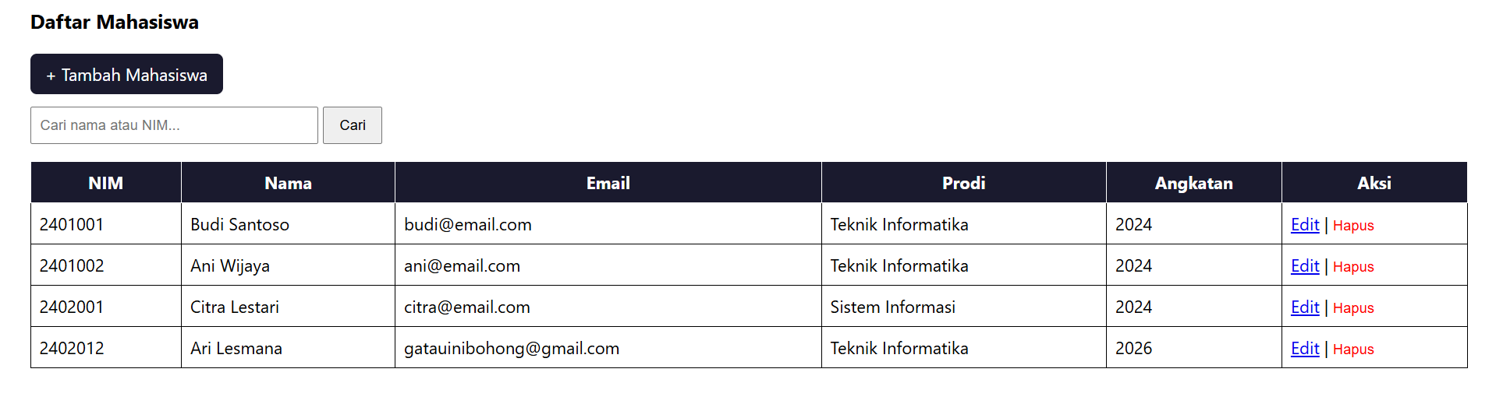
- Ulangi untuk Prodi dan Mata Kuliah.
- Pastikan JOIN digunakan saat menampilkan daftar mahasiswa (tampilkan nama prodi).
public function all(): array
{
$sql = "SELECT m.*, p.nama AS prodi_nama
FROM mahasiswa m
JOIN prodi p ON m.prodi_id = p.id
ORDER BY m.nim";
return $this->db->query($sql)->fetchAll();
}

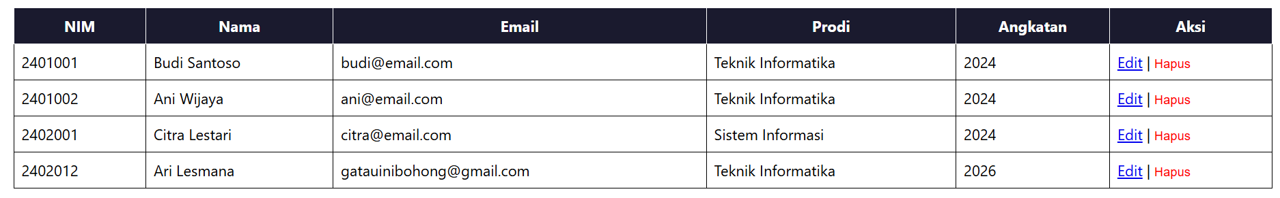
- Tambahkan konfirmasi JavaScript sebelum hapus.
<form method="POST" action="<?= $base ?>/mahasiswa/<?= $mhs['id'] ?>/delete"
style="display:inline;"
onsubmit="return confirm('Yakin ingin menghapus mahasiswa ini?');">
<button type="submit" style="background:none; border:none; color:red; cursor:pointer; padding:0;">Hapus</button>
</form>

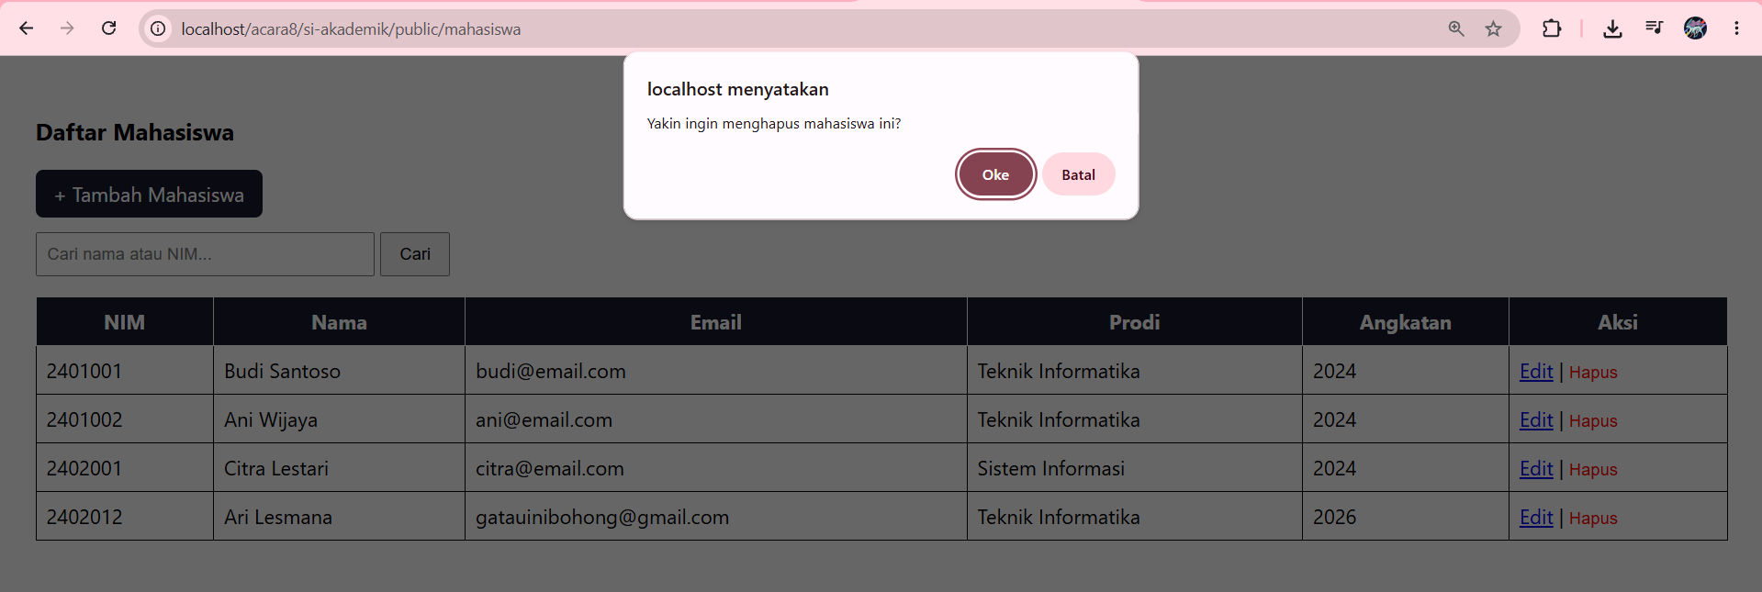
- Tugas Mandiri
Tambahkan fitur pencarian (search) pada halaman index mahasiswa berdasarkan nama atau NIM, menggunakan LIKE dengan prepared statement.
- Menambahkan code app/Models/MahasiswaModel.php
public function search(string $keyword): array
{
$sql = "SELECT m.*, p.nama AS prodi_nama
FROM mahasiswa m
JOIN prodi p ON m.prodi_id = p.id
WHERE m.nama LIKE :keyword OR m.nim LIKE :keyword
ORDER BY m.nim";
$stmt = $this->db->prepare($sql);
$stmt->execute(['keyword' => "%{$keyword}%"]);
return $stmt->fetchAll();
}
- Menambahkan code app/Controllers/MahasiswaController.php
$keyword = trim($_GET['q'] ?? '');
$daftarMahasiswa = $keyword !== ''
? $model->search($keyword)
: $model->all();
- Menambahkan code app/Views/mahasiswa/list.php
<form method="GET" action="<?= $base ?>/mahasiswa" style="margin-bottom:16px;">
<input type="text" name="q" placeholder="Cari nama atau NIM..." value="<?= htmlspecialchars($_GET['q'] ?? '') ?>" style="padding:8px; width:250px;">
<button type="submit" style="padding:8px 14px;">Cari</button>
<?php if (!empty($_GET['q'])): ?>
<a href="<?= $base ?>/mahasiswa" style="margin-left:8px;">Reset</a>
<?php endif; ?>
</form>

- Output
